|  |  |
| --- | --- |
| Project title | Separate and Mulitphysics Effects IRPhEP Benchmark Evaluation using SNAP Experiments |
| Federal Grant | DE-NE0009217 |
| Reporting Period | 4th Quarter FY 2022 |
| Contributors | Dan Kotlyar, Georgia Institute of Technology (GT)  Bojan Petrovic (GT), Isaac Naupa (GT)  Ben Lindley (University of Wisconsin-Madison, UW),  Sam Garcia (UW)  Shane Stimpson, BWX Technologies (BWXT),  Mark DeHart, Idaho National Laboratory (INL). |
| Submission Date | 10/31/2022 |

*This page is intentionally blank.*

|  |  |
| --- | --- |
| Project title: | Separate and Mulitphysics Effects IRPhEP Benchmark Evaluation using SNAP Experiments |
| Federal Grant: | DE-NE0009217 |
| Document Number: | NE-9217-GT-2022-Q4 |
| Reporting Period: | 4th Quarter FY 2022 |
| Submission Date: | 10/31/2022 |

|  |  |
| --- | --- |
|  |  |
|  |  |

This research is being performed under funding received from the U.S. Department of Energy Office of

Nuclear Energy’s Nuclear Energy University Program under contract number DE-NE0009217.



# Executive Summary

The SNAP program used a design-build-test-iterate approach for reactor development. This program yielded a considerable amount of documented experimental data. The two main objectives pursued in the current period are to:

1. **Perform systematic assessments of the experimental data with meticulous compilation and documentation, with the end objective of creating an evaluation compliant with the IRPhE evaluation guide [2].**

We have focused on collecting and documenting engineering drawings as well as collecting detailed description on the reactor tests and input parameters such as dimensions and material loadings. The SNAP-8 experimental reactor core included 215 fuel elements accepted for use, of which 211 fuel elements were assembled in the S8ER core. Each fuel rod is in the form of a solid hydride uranium-zirconium alloy.

The following specific tasks were accomplished:

* Collecting materials and dimensions specifications. This task included enrichments, mass loadings, poison materials, and reflectors materials and dimensions (Task 1.1).
* Collecting thermophysical properties is work-in-progress but is not reported here as our focus is to validate dry experiments (Task 1.2).

**2. Validate the performance of Serpent and Griffin to model effects against a set of dry experiments.**

A prototype reactor core and reflector assembly manufactured for the SNAP-8 experimental reactor was subjected to a series of dry critical experiments. The following subtasks were carried out:

* Collecting neutron data required for Serpent-Griffin validation (Task 2.1). Serpent was used to generate multi-group cross sections. The Serpent-Griffin two-step computational workflow was used to build a full core model in Griffin.
* Critical loadings - dry core (Task 2.2). These dry experiments were used to validate Serpent and Griffin.

Table of Contents

Executive Summary 4

1. Introduction 6

2. Supporting Computational Frameworks 7

*2.1* Open-Source Database - `*snapReactors`* 7

*2.2* Automated Generation of Inputs - `SIMBA` 8

3. Experiments & Physical Data 9

*3.1* General Overview of Experiment 9

*3.2* Experiment Geometry and Measurement Procedures 10

3.2.a Critical Configuration 13

*3.3* Materials 14

*3.4* Temperatures 15

4. Benchmark Models Insufficiency Report 15

5. Benchmark-model Specifications 15

*5.1* Model Simplifications 15

5.1.a Burnable Poison 15

5.1.b Unmodeled Components 16

*5.2* Benchmark-model Geometry 16

*5.3* Materials and Benchmark Model 18

*5.4* Expected Benchmark Values 22

6. Sample Calculated Results 24

7. Summary and Conclusions 25

8. Future work 25

9. Noteworthy Accomplishments 26

10. References 26

Acknowledgments 27

Appendix 1. ANS Winter Conference Paper 28

Appendix 2. IRPhEP Format Guidelines 29

# Introduction

The goal of this project is developing an IRPhEP-styled multiphysics microreactor benchmark evaluation leveraging experimental data from the SNAP program. SNAP systems share similar characteristics to modern microreactor designs such as power output, compact core design, high temperature solid moderators, and alkali-metal working fluid. The resulting benchmark would then be used for validation purposes of specific NEAMS tools for microreactor applications. The end objective is to qualify these tools as design and potential licensing tools in the context of microreactor technology. For this specific project we mainly focus on Griffin [2] and Bison, with potentially utilizing Pronghorn and SAM to perform thermal hydraulic tasks.

The SNAP 8 Experimental Reactor is chosen as the main design for the benchmark as it has the most abundance of experimental data and general documentation. The SNAP10A and SNAP2 systems are also well documented and have a variety of experimental data. Although the latter experiments may also be leveraged the current report focuses solely on the SNAP 8 Experimental Reactor Criticality Experiments [1]. The experiments are separated into the classification of dry-experiments and wet-experiments where dry refers to experiments operated at zero power and no coolant running through the system while wet refers to experiments that observed operational conditions. Here, the data compilation, code-to-code verification, and validation tasks are performed for the dry benchmarks.

The main dry experiments analyzed are the criticality configuration experiments. These experiments focused on various configurations regarding fuel element pattern loading, control drum orientation, and control element worth. The main quantity of interest is the system effective multiplication factor, as previous computational efforts have shown that it is the most difficult to capture [1]. The traditional 2-stage approach is used here where the Monte Carlo, Serpent, code is used to generate data and the core calculations are performed with Griffin [2] – a deterministic finite elements MOOSE-based code. To ensure the fidelity of the pre-generation stage, a reference model is developed and validated against the criticality configuration experiments. Specifications and assumptions used for the reference model are documented and discussed.

This report presents some of the computational frameworks being developed to achieve the goals of the project along with their motivations and impacts with regards to the general nuclear engineering community. In addition, we report presents the verification and validation of specific MOOSE tools including a thorough documentation and compilation of experimental data analyzed.

# Supporting Computational Frameworks

A multiphysics benchmark evaluation compliant with the IRPhEP evaluation guide requires systematic assessments of experimental data with meticulous compilation and documentation. Therefore, we are developing a SFCOMPO styled database and an automated consistent computational sequence for modeling purposes.

The SFCOMPO ***styled database*** will have the following attributes:

* Contain all relevant data for benchmark for various SNAP systems.
* Object orientated structure allowing for clean organization and data handling.
* Inherently dynamic structure that allows easy removal and/or addition of information.
* Post processing methods that are easily translated to model inputs in Serpent and Griffin.

The ***automated multiphysics sequence*** will have the following attributes:

* Provide set of functions and utilities for common workflows in reactor based multiphysics analysis.
* Aid in modeling sensitivity studies used for demonstrating the accuracy and quantifying the error or bias uncertainty of reactor physics calculations.

Both developments take the form of python-based packages with proper documentation, error checking, and unit testing. The SFCOMPO styled databased package is called ‘snapReactors’ while the package supporting the automated multiphysics sequence is called ‘SIMBA’ (Serpent Interface for Multiphysics Based Applications). These packages are open source and are hosted on public repositories for use of the nuclear engineering community.

The snapReactors-SIMBA workflow is developed to facilitate the creation of Serpent input files to be used in multiphysics applications. The Serpent input files can be become intricate and extensive when dealing with large problems that require different physical phenomena to be captured. This necessitates SIMBA to make the workflow more practical when doing these types of analyses. snapReactors is a database that host well documented experimental data for a variety of reactors under the SNAP Program [1]. Currently, a snapReactors-SIMBA workflow is being established which takes data directly from the snapReactors database and creates tailored Serpent input files. As a test case, this sequence will be compared against traditional manual modeling for all criticality configurations for the SNAP 8 Experimental Reactor in the ANS Winter Paper [3].

## Open-Source Database - `*snapReactors`*

The database is meant to be structured in a similar fashion to SFCOMPO which aims to facilitate the search and visualization of experimental data from nuclear spent fuel [4]. The snapReactors package aims to do this as well but at a much larger scale, including data from isotopic compositions of materials, material thermophysical and mechanical properties, dimensions, and operational conditions. All data stored in the database is documented appropriately with references and verified calculations. In this way the database can be used for validation purposes. The database is built as a python package and structures the data in a collection of containers aimed at providing easy access and navigation of data. The database will also have a suite of functions for added functionality such as exporting data in useful formats i.e., HDF5/ XML files.

**Figure 2‑1:** Snapshot of Database Object Oriented Hierarchical Structure.

## Automated Generation of Inputs - `SIMBA`

Serpent input files can be become intricate and extensive when dealing with large problems that require multiple physical phenomena to be captured. Traditionally this requires for the user to tailor the construction of the input file in a manner that would capture the appropriate phenomena, i.e., discretization of fuel pins for cross-section generation, imposing temperature and density fields, imposing material grading distributions., etc. If not done so manually, often “back of the envelope” scripting is done to facilitate the creation of the input file. While these scripts are sufficient, they are frequently focused on a specific problem and are not well documented and/or readily available for the broader community. Typically, most of the effort associated to such analyses is spent on setting up the tools and scripts. SIMBA aims to reduce the time spent setting up the workflow by providing a set of functions and utilities that can be easily adopted for common workflows in reactor based multiphysics analysis.

The SIMBA package takes traditional universe based Boolean geometry and organizes it in an object-oriented fashion into distinct containers with their appropriate attributes and methods. A set of functions called builders use these objects to create typical universe-geometry objects used in computational reactor analysis. A sample figure of a fully automated model of the S8ER with applied temperature and density fields is shown in Figure 2‑2.

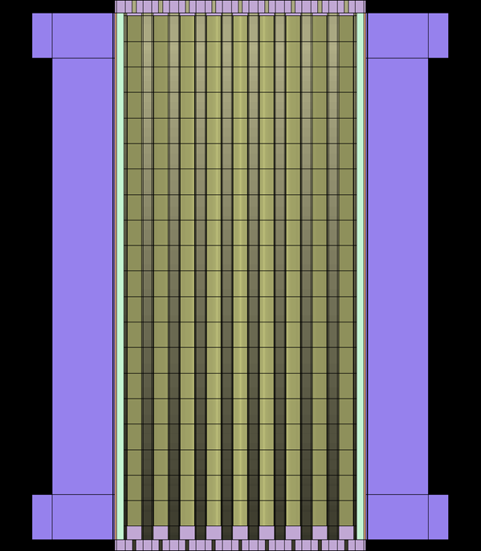

**Figure 2‑2:** Axial view of S8ER core with applied density and temperature fields.

# Experiments & Physical Data

## General Overview of Experiment

* Dates: May 19, 1963 – April 15, 1965 [5]
* Location: North American Aviation Field Test Area, SNAP Critical Facility Building 373 [6]
* Purpose: Demonstrate microreactor operation and determine reactor performance characteristics over various power levels and core temperatures up to and including design conditions.
* Design Objectives [5]:
  + Power output up to 600 kWth
  + 10,000-hour operational lifetime
  + 1300 °F (~705 °C) NaK outlet temperature
  + 350 lb (~159 kg) reactor weight
* Varied parameters over all experiments [5] [6]:
  + Reflector Shim geometry and ordering
  + Fuel and dummy pin loading schemes
  + Reflector Drum orientation
  + Varied Hydrogen and U235 densities in fuel pin
  + Unique control mechanisms
    - Burnable poison composition
    - Boronated rod in assembly
    - Poison Spline
  + Internal Reflector loading
  + Coolant flow rate
  + Coolant Temperature
  + Operational Time
* Over 40 experiments were evaluated throughout the lifetime of the S8ER.

Section 3 will focus on the dry critical experiments done for the S8ER as that has been the focus of the work done thus far.

## Experiment Geometry and Measurement Procedures

The S8ER was an epithermal microreactor utilizing reflector control elements with highly enriched Uranium-Zirconium Hydride (UZrH) fuel in a triangular fuel lattice within the core. An assembly view of the reactor and sectional view of a fuel element are shown below in Figure 3‑1. It should be noted that dimensions provided in the sectional view of the fuel element are nominal and less precise than tabulated values in reference.

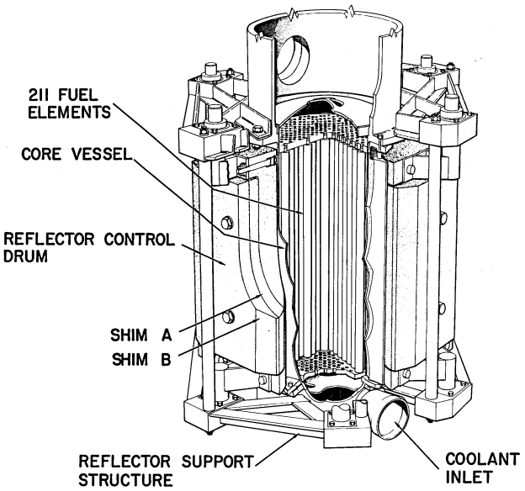

**Figure 3‑1**: Assembly view of S8ER core and fuel design with some components outlined [6].

From Figure 3‑1 we note that the core vessel contains 211 fuel elements, has coolant flowing from the bottom of the core region through the top, and is radially surrounded by reflector material. Although not clearly shown, there are stationary Beryllium reflectors that are seated between the control drums and the core vessel. Figure 3‑2 provides axial and radial views of the S8ER with more labeling for components that are not clearly visible in Figure 3‑1.

**Figure 3‑2**: Axial and radial view of S8ER core with labeled components [6].

In Figure 3‑2 we note that the reflector shim plates are attachments that are fastened within the reflector control drums. While not showcased in either of the figures above, there are eighteen internal reflector inserts that are located within the core vessel adjacent to the fuel elements, which are composed of Beryllium Oxide. Components integral to dry experiment neutronics simulations along with their dimensions as provided by Ref. [6] are presented in Table 3‑1. Note that the components and their material data are shown in Table 3‑2.

**Table 3‑1**: S8ER component dimensioning and geometry in inches and cm.

|  |  |  |  |
| --- | --- | --- | --- |
| **Component** | **Dimension Type** | **Dimension [in]** | **Dimension [cm]** |
| Reactor Vessel | Outside Diameter | 9.3520 | 23.75408 |
| Core Region Thickness | 0.0626 | 0.15900 |
| Upper Head Region Thickness | 0.2500 | 0.63500 |
| Lower Head Region Thickness | 0.1250 | 0.31750 |
| Upper Head Height | 3.5000 | 8.89000 |
| Lower Head Height | 4.0000 | 10.16000 |
| Overall Height | 24.0000 | 60.96000 |
| Reflecting Drums | Length | 14.5000 | 36.83000 |
| Radius of Curvature | 4.6800 | 11.88720 |
| Effective Thickness (No Shims) | 2.3400 | 5.94360 |
| Reflector-to-Core Radial Gap | 0.0818 | 0.20777 |
| Reflecting Shims | Length | 12.0000 | 30.48000 |
| Shim A Thickness | 0.7500 | 1.90500 |
| Shim B Thickness | 0.8800 | 2.23520 |
| Shim C Thickness | 1.1300 | 2.87020 |
| UZrH Fuel Elements | Length (no grid pins) | 14.4690 | 36.75126 |
| Outside Diameter | 0.5620 | 1.42748 |
| Fuel Rods | Length | 14.0000 | 35.56000 |
| Outside Diameter | 0.5320 | 1.35128 |
| Fuel-to-Clad Radial Gap* | 0.0016 | 0.00406 |
| Fuel-to-Clad Axial Gap* | 0.0240 | 0.06096 |
| Ceramic Coating Thickness* | 0.0022 | 0.00559 |
| Cladding Thickness* | 0.0104 | 0.02642 |
| Upper End Cap Thickness | 0.0800 | 0.20320 |
| Lower End Cap Thickness | 0.3700 | 0.93980 |
| Core | Length | 14.0000 | 35.56000 |
| Triangular Lattice Pitch | 0.5700 | 1.44780 |
| Diameter Across Corners | 9.2500 | 23.49500 |
| Diameter Across Flats | 9.0000 | 22.86000 |
| Equivalent Core Diameter | 8.6940 | 22.08276 |
| Upper Grid | Thickness | 0.3440 | 0.87376 |
| Lower Grid | Thickness | 0.3130 | 0.79502 |
| Coolant Flow Baffle | Thickness | 0.0625 | 0.15875 |
| Diameter | 9.1875 | 23.33625 |

Dimensions for the flange, drive shaft, reflector & control drum support structure, NaK coolant inlet, and control drum bushing were not provided as they were reported as less significant to neutronic analysis [6]. Quantities labeled with an asterisk* are noted as being nominal mean values across all 211 fuel elements. Additionally, there are no uncertainties listed or associated with the above dimensions from source references. Dimensions’ uncertainties will be ascertained through collaborative efforts with BWXT and will be a primary focus moving forward.

Experimental techniques for reactivity adjustments were done through four primary methods [6]:

* Changing fuel loading.
* Control drum & shim configurations.
* Control drum positioning.
* Introducing and removing elements and material of various moderating, capturing and fissile capabilities.

The array of fuel was partitioned into nine rings. Neutron reflector drums were rotated up to 105° out from the IN position to insert negative reactivity. The fuel element array along with the drum control scheme are shown below in Figure 3‑3.

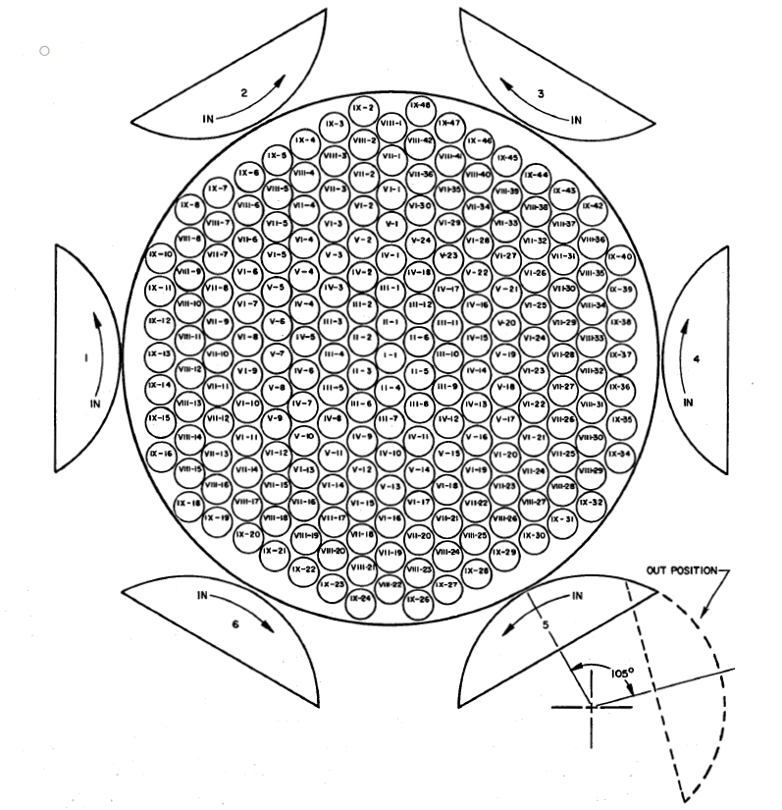

**Figure 3‑3**: Fuel element array and control drum positioning [6].

In every experiment the reactor operator was physically limited to insert less than 50¢ of excess reactivity to prevent prompt criticality behavior. This was done by locking a drum in the OUT position and restricting the rotation of at least one drum. Excess reactivity insertions were measured in terms of the stable reactor period, which was obtained from semilog plots or least-square fitting of the counts vs time from at least two instruments; detection instruments were never specified. The reactor period was converted to reactivity using the six-group Inhour equation, with an assumed effective delayed neutron fraction of 0.0077 [6].

Subcritical reactivity insertions were measured in terms of inverse multiplication plots. Incremental fuel additions were limited to twelve fuel elements or no more than half of the extrapolated fuel elements necessary for criticality, whichever was smaller. When criticality was extrapolated to be within two fuel elements, one fuel element was added at each step. Similarly, drum reactivity insertions near critical were limited by inverse multiplication extrapolations to produce a stable period of at least 20 seconds. Alternative methods of subcritical reactivity measurements were deemed unsuccessful. A Pu-Be source of 2E+6 neutrons/second was utilized for subcritical monitoring [6].

### Critical Configuration

The initial loading approach to criticality started with 211 dummy lucite rods with six internal reflectors lining the core wall. Lucite is an acrylic plastic that is transparent to neutron interaction, thus the lucite rods were replaced with loaded fuel-moderator elements as reactivity loading was increased [6]. The loading always began from one side of the core which resulted in crescent-shaped asymmetrical loading patterns. The first configuration, C-1, is explicitly outlined in documentation and shown below in Figure 3-4.

**Figure 3‑4**: C-1 lucite and fuel loading pattern [6].

## Materials

Material compositions of components outlined in Table 3‑1 are shown below in Table 3‑2, along with their densities and mass loadings when specified.

**Table 3‑2**: S8ER material composition and information.

|  |  |  |  |  |
| --- | --- | --- | --- | --- |
| **Component** | **Material** [6] | **Density [g/cm3]** | **Mass Loading** | **Misc. Comments** |
| Reactor Vessel | SS316 | 7.87 [7] | - | - |
| Reflecting Drum | Be | 1.84 | - | - |
| Reflector Shims | Be | 1.84 | - | - |
| Stationary Reflectors | Be | 1.84 [6] | - | - |
| Internal Reflectors | BeO | 3.02 [6] | - | - |
| Hastelloy-N | 8.86 [8] | - | - |
| Fuel Rods | UZrH | 6.06 [6] | 6.44 kg [6] | In Ref. [5] loading is listed as 6.56 kg |
| He | 1.574E-5 [9] | - | - |
| AI8763D | 2.8 [10] | - | - |
| Sm2O3 | 8.35 [6] | 8.51 [6] | Linear density listed as 2.88 mg/in |
| Hastelloy-N | 8.86 | - | - |
| Dummy Pins | Lucite | 1.19 [11] | - | - |
| Upper Grid | SS316 | 7.95 | - | - |
| Lower Grid | Hastelloy-C | 8.89 [8] | - | - |

Note that no uncertainties are present as they were not indicated in SNAP documentation. These will be determined independently.

## Temperatures

All measurements were obtained with the assembly at constant room temperature which was reported to be approximately 75°F (~24°C) [6].

# Benchmark Models Insufficiency Report

Dimensions indicated in references are not always obvious, and often left without description or inconsistent between different reports. Dimensions listed in Ref. [6] were chosen when inconsistencies appeared, although other reports were utilized when otherwise not provided. Furthermore, some figures are ambiguous and are not dimensioned as seen in Figure 3‑1 and Figure 3‑2. To this end, in the absence of data best judgement was used and when possible guided by illustrations provided in references.

Material loading specifications were inconsistent between references, such as the total burnable poison loading and the uranium loading. Values were defaulted to match those seen in Ref. [6] to conform to conditions seen during the dry critical experiments. Future work will attempt to quantify the impact of different loading specifications on reactor behavior by performing sensitivity analysis.

Yellow = Finished but Needs Written-up Updated

## Preliminary Criticality Configuration Case Studies

Here looking at trends for the experimental and modeled effective multiplication factor one can see that the modeled case C4 is inconsistent with the experimental data, where the experimental case C4 has a higher effective multiplication factor than C3, while the modeled C4 case has a lower effective multiplication factor then C3.

Here looking at a psuedo collective shim worth for each configuration and comparing against the difference in agrrement between modeled and experiemtal reactivity. The pesudo shim worth is calculated taking into account the presence of shimA , shimB, number of lucite rods, and number of drums locked out. One can see that there are discrpencies again in the modeled case C4, where C5 being nearly identical in configuration with the exception of the locked out drum No. 6. This also implies that there are discrepancies present in cases C1 & C2 as their difference in agreement is much higher than cases C4 & C5 for the nearly the same psuedo shim worth. The differences can be isolated to the lucite rods as cases C1 & C2 have much higher lucite rod loading. Studies should examine the effect of modeling a locked out drum as simply void compared to modeling the drum locked at 105 degrees. Modeling the locked out drum as a void region could significantly overestimate the local leakage causing underestimation in the effective multiplicaiton factor. Studies regarding the material composition of lucite should be performed as the current lucite composition is not directly taken from documentation but instead extrapolated from external sources, a variety of compositions should be samped and sensitivty studies should be performed.

The effect of thermal scattering should be considered with regards to the following bound scatterers in the following materials, hydrogen, berrylium, and carbon for the fuel rods(UZrH), lucite rods(HCO), and internal reflector (BeO). Preliminary studies have shown significant improvements in agreement since currently all cases over estimated the effective multiplication factor. Without thermal scattering corrected cross section treatment, the moderation power of the system is being over estimated and hence the fuel utilization factor is being overestimated leading to a higher system effective multiplication factor. Inclduing thermal scattering corrected cross section libraries for the materials discused would lead to significant improvement in agreement with results.

## Verification Studies

Green = Completed

* Verification of Beta and Lambda effective from section G, in NAA-SR-9642
  + Results found in serpent.res_m file
  + Use equations 6-29,6-30 from Duderstadt to verify
* Verification of total Sm2O3 poison core loading
  + 8.51 g resulting in a half radius worth of -272 cents, from section E.3 in NAA-SR-9642
* Verification of sm2o3 worth
  + 2.3 cents relative to void at center, section E.2 NAA-SR-9642
* Verification of Lucite loading and worth
  + Results from 1st row in Table 6 section E.1 NAA-SR-9642
    - Including lucite rod weight, and worth relative to worth
* Verification of fuel rod worth for varying positions
  + Results from Table 7
    - Breakdown of material worths in fuel rod for center, half, and periphery

General requirements for automated sequence and verification of case studies:

#### Method of verification for isotopic composition

* Method of verification for volumes and associated volume fraction
* Create C1-C5 with SIMBA, automate perturbations for specified sensitivity studies i.e.,
  + Perturbing Lucite density +- 3 sigma, and sample various compositions (check porosity)
  + Iterating on control drum thickness for each respective shim volume
    - Ring effective thickness of control drums/shims, see snap 8 nuclear analysis
    - Reference NAA-SR-9754

### Verification of Fuel & Special Elements Composition and Worth

Experiments regarding reactivity worths of various fuel and special elements were made by adjusting the fuel loading, control shim configurations, control drum positions, and introduction of special elements which either add or remove reactivity. The main method of measuring the excess reactivity of a configuration would be derive from a measurement of the stable reactor period. The Inhour equations were used to convert the reactivity into cents where an effective delayed neutron fraction of .0077 was used for the analysis. Other benchmarks regarding experimental reactors have determined that the measurement of the stable period is often the largest source of error pertaining to the entire experiment [2]. All reactivity increments were made intentionally to result in a period of 20 seconds or more. Where the experiments were conducted at 297 K. At all times the excess reactivity was limited to 50 cents or 385 pcm. The core loading originally starts with 211 Lucite dummy elements, where the Lucite elements are replaced by fuel elements as the loading is increased. All 211 elements are always filled, with exception to void worth measurements. For partially fueled critical loading configurations, the Lucite region filled a crescent like shape to one side of the reactor as shown below.

Fuel composition verification

Core Material Composition Verification

Critical Configuration Experiments

Critical configuration C-4 was the reference condition for the power distributions and the and worths of various fuel elements and was representative of that of a fully fueled core. Comparing against computational modeling efforts of a diffusion-based code, had significant error due to a small number of thermal energy groups, and was sensitive to effective reflector thickness.

C1 - Configuration

C2 Configuration

C3 Configuration

Radial Reflector Worth Experiments

The radial reflector control drum system was designed to have additional shims be easily attached for a variety of effective reflector thickness and shim worths. Experiments regarding the worth of the shims were performed. Single shim worths as well as total shim worths are reported. Single shim worth was determined from removing a single shim on an individual drum from the entire configuration and measuring the reactivity loss. Total shim worth was determined by multiplying the single shim worth by the total number of shims. Comparing against computational efforts with a more refined energy group structure (40 groups), specifically in the thermal range, where variations in effective reflector thickness have a significant impact on the spectrum, results improved from the previous diffusion code.

Power Distributions

The power distribution was measured using a special fuel rod which contained 7 segments each 2 in thick. Where the top segment had no hydrogen content and the rest contained standard hydrogen and uranium content.

Axial Power Distribution

Radial Power Distribution

Special Fuel Rods and Absorbers

The worths of various fuel element configurations and special absorbers were tested. These elements worth relative to void are documented below.

Extrapolating results from the previous table, relative worth to void can be established for a standard fuel rod at various radial positions in the core.

Burnable Poison Worth

The poison worth of the SM2O3 coating was determined to be 2.3 cents at the center of the core. This was determined by taking an empty fuel can and subtracting the worth of the empty fuel can alone from the worth of the burnable poison coating lined empty fuel can.

The worth of Samarian oxide was measured at two locations and the worth per gram of Samarian oxide was also documented.

Taking a rough estimate that the worth of sm2o3 at the half radius is representative of the core average worth, the initial worth of the total sm2o3 loading in the core is -272 cents. Given the initial sm2o3 loading is 8.51 g.

Sensitivity Studies

To perform the sensitivity studies, the Serpent perturbation module will be used. The module implements Generalized Perturbation Theory (GPT). GPT is popular amongst nuclear data analysis because of its favorable characteristics which allow to observe the effect on a certain parameter based on a response function without explicitly performing separate direct perturbations. The method is based upon the collision history of each particle which are used to create the response function in which the perturbations are applied [1].

References:

* [1] Aufiero, M. et al. “A collision history-based approach to sensitivity/perturbation calculations in the continuous energy Monte Carlo code SERPENT”, Ann. Nucl. Energy, 152 (2015) 245-258.
* [2] Fratoni, Massimiliano, Shen, Dan, Ilas, Germina, & Powers, Jeff. Molten Salt Reactor Experiment Benchmark Evaluation. United States. https://doi.org/10.2172/1617123

# Benchmark-model Specifications

## Model Simplifications

Computational modeling for neutronics analysis was done in Serpent utilizing Idaho National Laboratory’s High Performance Computing resources [2]. The dry critical experiments were modeled with the initial primary focus on the critical loading experiment. The S8ER assembly was loaded with four unique configurations that varied fuel-moderator elements, reflector shim installment, and drum rotation to the OUT position. In modeling these experiments, some simplifications were made:

* Coolant baffle plate was not modeled.
* Coolant inlet and outlet regions were not modeled.
* Supporting structures for reflecting element were not modeled.
* Fasteners for neutron reflector shim was not modeled.
* Thermocouples were not modeled.
* Internal reflector tie rod pins were not modeled.
* Internal reflectors were modeled based on reference volume fractions with suitable void material.
* Internal reflector thickness was modeled to follow illustrations.
* Burnable poison was modeled as separate layer rather than built into AI8763D ceramic.

### Burnable Poison

The burnable poison was modeled as a separate layer by utilizing the specified linear mass density as well as the total poison loading over all elements. The cross-sectional area of the poison can be deduced by taking the ratio of the linear density over mass density. The outer radius of the poison was assumed to be seated in between the ceramic and the cladding which means the outer radius was known. The inner radius of the poison must be determined to correctly model this simplification in Serpent. The inner radius is determined with Equation 5-1 below, where is the inner poison radius, is the outer poison radius or the inner clad radius, and is the cross-sectional area.

The axial thickness of poison must be computed as well for the top portion of the fuel element. To do this, the radial mass of fuel was evaluated through simple mass density relations over the height of the fuel pin. This mass is then subtracted from the poison mass loading per fuel element implied from the total poison loading. This is shown below in Equation 5-2, where is the poison mass loading per fuel element and is the density of the poison.

E-5 g (5-2)

A volume is determined the taking the ratio of and poison density from which a thickness is extracted as shown in Equation (5-3).

E-7cm (5-3)

As indicated in Section 5-2, all other dimensions and parameters within the fuel pins remained consistent with reference.

### Unmodeled Components

While including unmodeled components would be necessary to maximize accuracy, their contributions to validating reactivity is expected to be relatively small while substantially increasing the complexity of the model. Furthermore, any small perturbations to reactivity they might induce are expected to be within uncertainty. To verify this is the case along with corresponding uncertainties, future work looks to homogenize material with appropriate volume fractions when possible, such as the case with the fasteners for the reflecting shims. Components not embedded within the active core structure, such as the supporting structure, will be coarsely modeled to evaluate their reactivity contributions.

## Benchmark-model Geometry

In Figure 5‑1, geometry of the core, shim, and drums are shown dimensioned in cm.

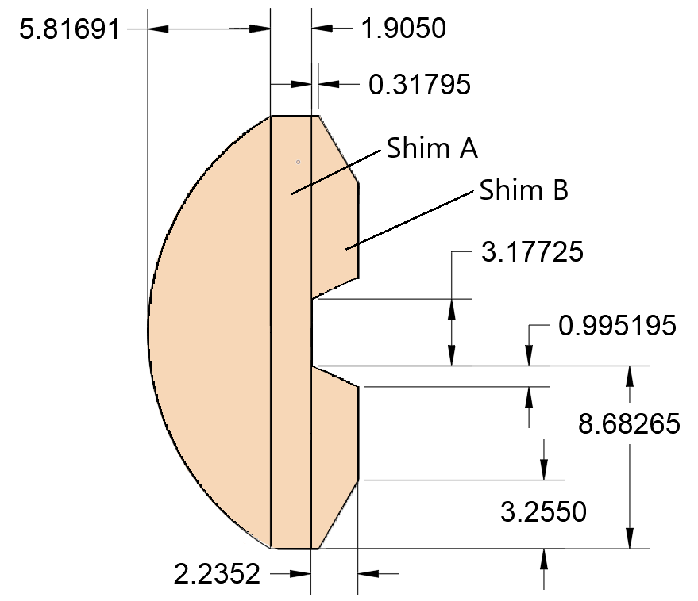

**Figure 5‑1**: S8ER core, reflector drum and shims dimensioned in cm.

The latest radial core model with all the above modeled is shown below in Figure 5‑2, note that the drums are numbered to follow experimental notes.

**Figure 5‑2**: S8ER core (xy view) modeled in Serpent.

Axial portions were then added to the Serpent model which is shown in Figure 5‑3 dimensioned in cm.

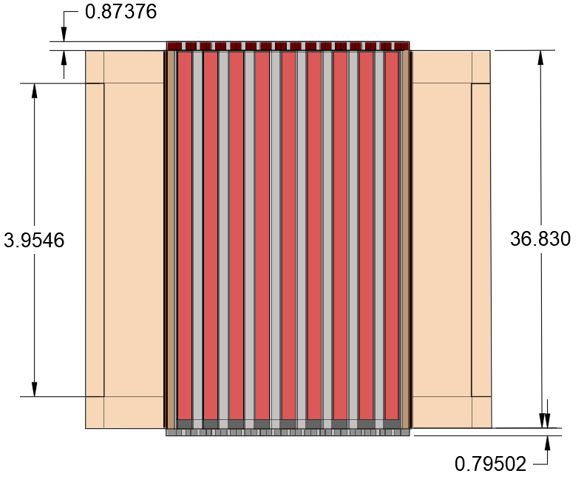

**Figure 5‑3**: S8ER core and reflector (xz view) dimensioned in cm.

The material that is present between the fuel elements seen in Figure 5‑3 above is air, which is assumed present in the core during the dry critical experiments. All dimensions shown in the figures above correspond to what is exactly noted in Table 3‑1, with the exception of those for the B shim as none were provided in reference.

## Materials and Benchmark Model

The atomic densities in atoms/(b-cm) that were utilized for this work are tabulated below in Table 5-1. The nuclides are identified according to the number of protons (ZZ) and nucleons (protons + neutrons, *i.e.*, AAA).

**Table 5‑1**: Isotopic material composition for all materials utilized in S8ER modeling [2].

|  |  |  |
| --- | --- | --- |
| **Material** | **Nuclide [ZZAAA]** | **Density [atoms/b-cm]** |
| Uranium Zirconium Hydride | 1001 | 5.96000E-02 |
| 1002 | 8.79000E-06 |
| 40090 | 1.83000E-02 |
| 40091 | 4.00000E-03 |
| 40092 | 6.11000E-03 |
| 40094 | 6.19000E-03 |
| 40096 | 9.98000E-04 |
| 92235 | 1.43000E-03 |
| 92238 | 1.04000E-04 |
| Hastelloy-C [8] | 14028 | 1.41333E-04 |
| 14029 | 6.86588E-06 |
| 14030 | 4.33981E-06 |
| 23051 | 3.67831E-04 |
| 24050 | 7.45215E-04 |
| 24052 | 1.38189E-02 |
| 24053 | 1.53735E-03 |
| 24054 | 3.75594E-04 |
| 25055 | 9.74540E-04 |
| 26054 | 2.90082E-04 |
| 26056 | 4.39125E-03 |
| 26057 | 9.96308E-05 |
| 26058 | 1.30305E-05 |
| 27059 | 2.27119E-03 |
| 28058 | 3.43243E-02 |
| 28060 | 1.27815E-02 |
| 28061 | 5.46477E-04 |
| 28062 | 1.71437E-03 |
| 28064 | 4.22939E-04 |
| 29063 | 2.94158E-04 |
| 29065 | 1.27194E-04 |
| 42092 | 1.36538E-03 |
| 42094 | 8.37243E-04 |
| 42095 | 1.43271E-03 |
| 42096 | 1.48925E-03 |
| 42097 | 8.47029E-04 |
| 42098 | 2.12544E-03 |
| 42100 | 8.35474E-04 |
| 6000 | 4.46120E-05 |
| 74182 | 3.11911E-04 |
| 74183 | 1.67509E-04 |
| 74184 | 3.56713E-04 |
| 74186 | 3.27418E-04 |
| Hastelloy-N [8] | 13027 | 4.95122E-04 |
| 14028 | 1.76327E-03 |
| 14029 | 8.56588E-05 |
| 14030 | 5.41435E-05 |
| 22046 | 2.39840E-05 |
| 22047 | 2.11690E-05 |
| 22048 | 2.05397E-04 |
| 22049 | 1.47653E-05 |
| 22050 | 1.38554E-05 |
| 23051 | 5.24465E-04 |
| 24050 | 3.25406E-04 |
| 24052 | 6.03421E-03 |
| 24053 | 6.71298E-04 |
| 24054 | 1.64007E-04 |
| 25055 | 7.78136E-04 |
| 26054 | 2.31621E-04 |
| 26056 | 3.50626E-03 |
| 26057 | 7.95517E-05 |
| 26058 | 1.04044E-05 |
| 27059 | 1.81346E-04 |
| 28058 | 4.33818E-02 |
| 28060 | 1.61542E-02 |
| 28061 | 6.90684E-04 |
| 28062 | 2.16677E-03 |
| 28064 | 5.34546E-04 |
| 29063 | 1.17437E-04 |
| 29065 | 5.07801E-05 |
| 42092 | 1.36276E-03 |
| 42094 | 8.35637E-04 |
| 42095 | 1.42996E-03 |
| 42096 | 1.48639E-03 |
| 42097 | 8.45404E-04 |
| 42098 | 2.12137E-03 |
| 42100 | 8.33871E-04 |
| 6000 | 2.67159E-04 |
| 74182 | 3.89141E-05 |
| 74183 | 2.08985E-05 |
| 74184 | 4.45036E-05 |
| 74186 | 4.08488E-05 |
| Stainless Steel 316 [7] | 6000 | 3.19301E-04 |
| 7014 | 3.40766E-04 |
| 7015 | 1.21187E-06 |
| 14028 | 1.18542E-03 |
| 14029 | 5.75871E-05 |
| 14030 | 3.63998E-05 |
| 15031 | 3.47948E-05 |
| 16032 | 4.28282E-05 |
| 16033 | 3.19029E-07 |
| 16034 | 1.67736E-06 |
| 16036 | 5.19387E-09 |
| 24050 | 7.08383E-04 |
| 24052 | 1.31360E-02 |
| 24053 | 1.46136E-03 |
| 24054 | 3.57030E-04 |
| 25055 | 1.74376E-03 |
| 26054 | 3.40069E-03 |
| 26056 | 5.14793E-02 |
| 26057 | 1.16799E-03 |
| 26058 | 1.52758E-04 |
| 28058 | 6.75407E-03 |
| 28060 | 2.51504E-03 |
| 28061 | 1.07532E-04 |
| 28062 | 3.37341E-04 |
| 28064 | 8.32229E-05 |
| 42092 | 1.90867E-04 |
| 42094 | 1.17039E-04 |
| 42095 | 2.00280E-04 |
| 42096 | 2.08183E-04 |
| 42097 | 1.18407E-04 |
| 42098 | 2.97117E-04 |
| 42100 | 1.16791E-04 |
| Beryllium | 4009 | 1.22951E-1 |
| Beryllium Oxide | 4009 | 7.27124E-2 |
| 8016 | 7.27330E-2 |
| Samarium Oxide | 8016 | 4.32706E-02 |
|  | 62144 | 9.25038E-04 |
| 62147 | 4.42440E-03 |
| 62148 | 3.29514E-03 |
| 62149 | 4.02422E-03 |
| 62150 | 2.13464E-03 |
| 62152 | 7.63533E-03 |
| 62154 | 6.40913E-03 |
| AI-8763D [10] | 3006 | 7.18410E-05 |
| 3007 | 1.20834E-03 |
| 8016 | 3.81971E-02 |
| 12024 | 8.73652E-05 |
| 12025 | 1.06640E-05 |
| 12026 | 1.13387E-05 |
| 14028 | 1.23620E-02 |
| 14029 | 6.00540E-04 |
| 14030 | 3.79592E-04 |
| 20040 | 4.46292E-04 |
| 20042 | 2.83692E-06 |
| 20043 | 5.78159E-07 |
| 20044 | 8.73102E-06 |
| 20046 | 1.60141E-08 |
| 20048 | 7.17452E-07 |
| 22046 | 1.80902E-04 |
| 22047 | 1.59669E-04 |
| 22048 | 1.54923E-03 |
| 22049 | 1.11369E-04 |
| 22050 | 1.04506E-04 |
| 25055 | 2.18593E-04 |
| 38084 | 1.02256E-06 |
| 38086 | 1.75861E-05 |
| 38087 | 1.23414E-05 |
| 38088 | 1.43944E-04 |
| 40090 | 3.56045E-04 |
| 40091 | 7.67899E-05 |
| 40092 | 1.16099E-04 |
| 40094 | 1.15148E-04 |
| 40096 | 1.81637E-05 |
| 56130 | 4.06703E-06 |
| 56132 | 3.64126E-06 |
| 56134 | 8.68031E-05 |
| 56135 | 2.34621E-04 |
| 56136 | 2.77428E-04 |
| 56137 | 3.93978E-04 |
| 56138 | 2.49721E-03 |
| Helium | 2004 | 2.36813E-3 |
| Air [12] | 7014 | 3.96609E-05 |
| 7015 | 1.41307E-07 |
| 8016 | 1.06659E-05 |
| 8017 | 3.71891E-09 |
| 18036 | 5.48238E-09 |
| 18038 | 1.07776E-08 |
| 18040 | 2.23616E-07 |

The atomic density of the zirconium hydride was computed directly from the loading of uranium for the dry critical experiments [6].Fuel specifications and dimensions were provided, while the volume of the fuel rod was computed and a mass density was taken as the average uranium loading per rod over the rod’s volume. The weight enrichment value of 93.15% was used to obtain atomic densities. It should be noted that while the number density of hydrogen is provided in reference, it is a nominal value whose uncertainty is not provided thus it was deemed appropriate to determine this manually.

Other atomic densities are computed directly from Serpent as the model was provided with fractional mass densities [13]. References near material names indicate sources for elemental fractions, which were then used in conjunction with Ref. [13] to evaluate isotopic mass fractions. This conversion to atomic densities via Serpent is accurate so long as the user provides a total mass density of the material, which they were. Serpent does not provide uncertainties with these computations thus none are provided. Future work will look to determine these uncertainties utilizing Ref. [13].

## Expected Benchmark Values

Ultimately, the full range of dry experiments will be modelled. Here, a preliminary analysis is performed of four critical experiments, to investigate the validity of the model. Recall Figure 3‑4 showcases the fuel-moderator element loading method utilized for the C-1 configuration. The exact loading arrangement for subsequent configurations, namely C-2 and C-4 were not explicitly shown. It was decided that the positioning of the lucite pins to model the critical loading scheme for C-2 and C-4 should remain consistent observed asymmetric crescent-shaped loading as seen in Figure 3-4. The resulting loading schemes used in Serpent are shown below in Figure 5-4

The initial loading approach to critical in the experiments was begun with 211 dummy lucite rods with six internal reflectors lining the core wall. Lucite is an acrylic plastic that is transparent to neutron interaction, thus the lucite rods were replaced with loaded fuel-moderator elements as reactivity loading was increased [6]. The loading always began from one side of the core which resulted in crescent-shaped asymmetrical loading patterns. The first configuration, C-1, is explicitly outlined in documentation and shown below in Figure 5‑4 [6].

|  |  |
| --- | --- |
|  |  |

**Figure 5‑4**: C-2 (left) and C-4 (right) loading pattern.

The results of the modeled critical loading schemes will be detailed in Table 6-1 which presents expected reactivity at each configuration. It is important that the uncertainty of these expected benchmark values are reported as having an uncertainty of “less than 1%” [6]. This has not been refined further which is why the uncertainties are left unreported in Table 6‑1.

# Sample Calculated Results

Results were computed utilizing Serpent 2.1.32 with ENDFB7 cross section libraries. At the time of this report analysis was done without the inclusion of thermal scattering libraries for Uranium Zirconium-Hydride. Preliminary results show that with the inclusion of thermal scattering libraries for UZrH, each case decreases by at least 300 pcm.

The critical loading schemes were run in Serpent for loading designations C-1 to C-5, where C-5 has the same loading scheme as C-4 with no drums locked out. The C-5 configuration was not actually assembled; however, a computed reactivity was reported. The results are shown below.

**Table 6‑1**: S8ER Critical Loading.

|  |  |  |  |  |  |
| --- | --- | --- | --- | --- | --- |
|  | **Loading Designation** | | | | |
|  | **C-1** | **C-2** | **C-3** | **C-4** | **C-5\*** |
| Shims installed | A & B | A | None | A & B | A & B |
| Drums locked out | None | None | None | No. 6 | None |
| Number lucite rods | 38 | 25 | 0 | 20 | 20 |
| Measured reactivity [cents] | 9.7 | 14.3 | -28 | 9.3 | 374 |
| Modeled reactivity [cents] | 241.76± 0.026 | 222.30±0.024 | 87.64±  0.0096 | 28.50±  0.0034 | 513.45±  0.049 |
| Measured Reactivity [k] | 1.0007 | 1.0011 | 0.9978 | 1.0007 | 1.0296 |
| Modeled reactivity [k] | 1.0196±0.00010 | 1.0181±0.00011 | 1.0071±0.00011 | 1.0023±0.00012 | 1.0423±0.00010 |
| Modeled vs. Measured Difference [pcm] | +1850±10 | +1670±11 | +920±12 | +160±12 | 1180±12 |

# Summary and Conclusions

The accomplishments of this report center around the completion of a reference model which will serve as the basis for the pre-generation stage of the 2-stage Serpent-Griffin workflow and the development of computational frameworks which aid in the creation of a multiphysics benchmark evaluation compliant with the IRPhEP evaluation guide. The report also includes thorough documentation of experimental data which will be required for the IRPhEP evaluation. This work sets the foundation to proceed with the separate physics evaluation and validate the 2-stage Serpent-Griffin workflow for microreactor applications.

Completion of reference model with the following clarifications/improvements intended:

* Improve modeling of external reflector control shim dimensions as these are not well documented.
* Remedy the incorrect modeling of “locked-out” control drums.
* Include all general reactor materials composition.

Demonstration of the SIMBA-snapReactors workflow:

* S8ER was modeled fully using the SIMBA package.
* Parameters were extracted from the snapReactors database.
* The automated sequence was validated against s manual model.

# Future work

Current work has developed a preliminary 2D model for the S8ER using the 2 stage Serpent-Griffin approach with preliminary results showing reasonable agreement with reference models. The model will be expanded to 3D and be compared against the S8ER criticality experiments for various configurations regarding fuel element pattern loading, control drum orientation, and control element worth.

Future work will focus on developing and expanding upon the following:

* Sensitivity studies regarding generation of the few group parameters, specifically focusing on spatial resolution and energy group structure and overall effect of homogenization
* Sensitivity studies regarding fidelity of unstructured mesh used in finite element analysis, effect of angular quadrature scheme and resolution, and effect of void regions and high anisotropy with respect to scattering moments.
* Quantifying the effect and uncertainty of various parameters on the 2 stage Serpent-Griffin approach for the S8ER and comparing against documented SNAP 8 Criticality Configuration experiments.
* Developing a generalized methodology for the 2 stage Serpent-Griffin approach for microreactor applications.

# Noteworthy Accomplishments

For **Samuel Garcia**:

* National Science Foundation (NSF) Graduate Research Fellow
* University Nuclear Leadership Program (UNLP) Fellow
* Graduate Engineering Research (GER) Fellow
* Presenting work on S8ER at 2022 ANS Winter Meeting and Technology Expo

# References

|  |  |
| --- | --- |
| [1] | L. D. Swenson, "SNAP 8 development reactor nuclear analysis," 1969. |
| [2] | J. LEPPANEN et al, "The Serpent Monte Carlo code: Status, development and applications in 2013," *Ann. Nucl. Energy,* vol. 82, pp. 142-150, 2015. |
| [3] | S. Garcia, "Validation of SNAP8 Critcality Configuration Experiments using SERPENT," in *ANS Winter Conference*, Phoenix, AZ, 2022. |
| [4] | F. Michel-Sendis, "SFCOMPO-2.0: An OECD NEA Database of Spent Nuclear Fuel isotopic Assays, Reactor Design Specifications and Operating Data," *Annals of Nuclear Energy,* 2017. |
| [5] | A. International, "SNAP 8 Summary Report," Atomics International, Canoga Park, 1973. |
| [6] | D. Crouter, "SNAP 8 Experimental Reactor Critical Experiment," Atomics International, Canoga Park, 1964. |
| [7] | AZO Materials, "Stainless Steel - Grade 316," AZO Materials, 2022. [Online]. Available: https://www.azom.com/properties.aspx?ArticleID=863. |
| [8] | Haynes International, "Corossion-resistant Alloys," Haynes International, 2021. [Online]. Available: https://www.haynesintl.com/alloys/alloy-portfolio_. |
| [9] | R. E. Lords, "ANSP and AI Fuel Summary Report," Westinghouse Idaho Nuclear Company, Inc., Silver Spring, Maryland, 1994. |
| [10] | R. W. Webb, "SNAP 8 EXPERIMENTAL REACTOR HYDROGEN BARRIER COATING DEVELOPMENT," Atomics International, Canoga Park, 1964. |
| [11] | National Institute of Standards and Technology, "Composition of POLYMETHYL METHACRALATE (LUCITE, PERSPEX, PLEXIGLASS):," NIST, [Online]. Available: https://physics.nist.gov/cgi-bin/Star/compos.pl?matno=223. |
| [12] | D. R. Lide, Handbook of Chemistry and Physics, Boca Raton: National Institute of Standards and Technology, 2017. |
| [13] | Comission on Isotopic Abundances and Atomic Weights, "Isotopic compositions of the elements," International Union of Pure and Applied Chemistry, 2021. [Online]. Available: www.ciaaw.org.. |
| [14] | J. LEPPANEN et al, "2D BWR fuel assembly geometry," 29 November 2017. [Online]. Available: https://serpent.vtt.fi/mediawiki/index.php/2D_BWR_fuel_assembly_geometry. |
| [15] | J. LEPPANEN, "On the use of delta-tracking and the collision flux estimator in the Serpent 2 Monte Carlo particle transport code," *Annals of Nuclear Energy,* vol. 105, pp. 161-167, 2017. |
| [16] | B. PAINTER, S. TERLIZZI and D. KOTLYAR, "Accelerated Coupled Monte Carlo-Thermal Hydraulic Calculations using a Hybrid GTF-Diffusion-based Prediction Block: First Results," in *International Conference on Reactor Physics*, Pittsburgh, 2022. |
| [17] | S. TERLIZZI and D. KOTLYAR, "On-the-fly prediction of macroscopic cross-section spatial response to TH perturbations through transfer functions: Theory and first results," *Nuclear Science and Engineering,* vol. 194, no. 4, pp. 280-296, 2020. |
| [18] | T. M. PANDYA et al, "Two-step neutronics calculations with Shift and Griffin for advanced," *Annals of Nuclear Energy,* vol. 173, pp. 109-131, 2022. |
| [19] | T. M. PANDYA et al, "Implementation, capabilities, and benchmarking of Shift a massively parallel Monte Carlo radiation transport code," *Journal of Computational Physics,* vol. 308, pp. 239-272, 2016. |
| [20] | S. S. Voss, "SNAP Reactor Overview," Air Force Weapon Laboratory, New Mexico, 1984. |

# Acknowledgments

This research made use of Idaho National Laboratory computing resources which are supported by the Office of Nuclear Energy of the U.S. Department of Energy and the Nuclear Science User Facilities under Contract No. DE-AC07-05ID14517. [4] [3]

# Appendix 1. ANS Winter Conference Paper

*See attached paper at the end of this report.*

# Appendix 2. IRPhEP Format Guidelines

*A pdf version of the IRPhEP guidelines and check list is included at the end of this report.*